**Expectation-Maximization (EM) and Newton-Raphson algorithms applied to the ABO example**

**Submitted to:** Dr. Lei Sun

**Submitted by:** Cristina Abbatangelo

**Subject:** Modern Statistical Genetics

**Course Code:** CHL5224

**Due Date:** Tuesday, October 6, 2020.

**Expectation-Maximization (EM) and Newton-Raphson algorithms applied to the ABO example**

# **Introduction**

“The life of the flesh is in the blood” (Leviticus 17:11). The history of the significance of blood is as long as the humans who encapsulate it. For centuries, curiosity surrounding both the symbolic and biological functions of blood motivated a myriad of advances. Assuming all blood to be the same, a question which physicians grappled with for some time was why some blood transfusions were successful while others could be fatal. It was not until 1900 that a hypothesis was put forth. Karl Landsteiner is credited with the discovery of the ABO blood group system while at the University of Vienna1. He mixed blood serum from his staff to demonstrate that some mixtures resulted in the agglutination of red blood cells1. These early experiments enabled him to identify three types: A, B and C. C was later named to O, representative of the German word “Ohne” which can translate to “without”, “zero” or “null” in English. The blood group AB was discovered just one year later, and in 1930, Landsteiner was the recipient of the Nobel Prize in physiology and medicine for his pivotal work2.

The gene that determines human ABO blood type is located on chromosome 9 (9q34.1)3. The ABO-locus has three main allelic forms: The A allele, the B allele and the O allele3. Each allele is responsible for the production of a specific glycoprotein. The combination of two inherited alleles at a locus (position on a gene) determines which glycoprotein (and attached antigen) is found on an individual’s red blood cells, and by extension determines that individual’s blood type4. **Table 1.1** indicates the possible parental combinations for each blood type.

|  |  |  |  |  |
| --- | --- | --- | --- | --- |
| **ABO genotype in the offspring** |  | **ABO alleles inherited from the mother** | | |
|  | **A** | **B** | **O** |
| **ABO alleles inherited from the father** | **A** | A | AB | A |
| **B** | AB | B | B |
| **O** | A | B | O |

**Table 1.1. Possible parental combinations for each blood type.** A child may receive one of three alleles from each parent, giving rise to six possible genotypes, and four possible blood types. Adapted from Dean, 2013.

As illustrated in the table above, a child may receive one of three alleles from each parent, giving rise to six possible genotypes, and four possible blood types. The reason for this is that the ABO blood system follows a unique co-dominant mode of inheritance5. A and B are co-dominant, which means that in the heterozygous form (when two different forms of an allele are present at a locus) they are both fully expressed. When A or B is paired with O, the O expression is masked by the dominance of the A or B allele, and therefore not expressed in the individual’s phenotype (observable characteristic resulting from the genotype)5.

**Table 1.2** illustrates the presence of antigens and antibodies for each of the four blood types and reinforces the co-dominance inheritance pattern.

|  |  |  |  |
| --- | --- | --- | --- |
| **Blood group** | **Antigen(s) present on the red blood cells** | **Antibodies present in the serum** | **Genotype(s)** |
| **A** | A antigen | Anti-B antibody | AA or AO |
| **B** | B antigen | Anti-A antibody | BB or BO |
| **AB** | A and B antigens | None | AB |
| **O** | None | Anti-A and Anti-B antibodies | OO |

**Table 1.22. Antigen and antibody presence for each blood group.** Blood group A possesses the A antigen and the Anti-B antibody, with possible genotypes of AA or AO. Blood group B possesses the B antigen and the Anti-A antibody, with possible genotypes of BB or BO. Blood group AB possesses both A and B antigens, as co-dominant alleles are always fully expressed in the heterozygous form, with no antibodies and the only possible genotype being AB. Lastly, blood group O does not possess any antigens on its surface but has both Anti-A and Anti-B antibodies in its serum, with the only possible genotype being OO.

Both tables highlight the notion that offspring receive one of three alleles from each parent, resulting in six possible genotypes (AA, AO, BB, BO, AB, OO), but only four possible phenotypes (A, B, AB, O). Importantly, one cannot infer an individual’s genotype from the observation of the phenotype alone. This inability to determine an individual’s genotype from phenotypic data sets the stage for a unique problem of missing data.

One way researchers have tackled statistical problems of missing data is by employing population genetics techniques. Population genetics is the study of changes in allele frequencies over time, both within and between populations6. Evolutionary forces such as natural selection and genetic drift can cause allele frequencies to change from one generation to the next6. Consider a scenario where an allele, let us call it A, confers an advantage for an organism in a given environment. It is likely that individuals who harbour the A allele will be more likely to survive and reproduce, and therefore the frequency of the A allele will increase in the next generation. But what if all alleles had the same probability of survival? Consider a second scenario where an allele, this time B, is present in a large population where there is no natural selection, no mutation, no migration and where individuals exhibit a random mating pattern. There is nothing occurring in this population to cause the allele frequency of B to fluctuate from one generation to the next, it would be expected to stay the same. This constancy was noted independently in 1908 by two researchers; German physician Wilhelm Weinberg and British mathematician Godfrey Harold Hardy7,8. When combined, the efforts lead to the establishment of an important mathematical representation of allelic frequencies, known as the Hardy-Weinberg equilibrium. **Box 1.1** outlines the equations and the assumptions of the Hardy-Weinberg equilibrium. The Hardy-Weinberg equilibrium applies basic rules of probability to a population, permitting predictions to be made about subsequent generations. As such, the Hardy-Weinberg equilibrium serves as the null model in many population genetics studies.

This project will apply the Hardy-Weinberg equilibrium, in conjunction with statistical methodologies, to ABO blood group phenotypic frequencies in order to make predictions of allelic frequencies.

|  |
| --- |
| **The Hardy-Weinberg Equilibrium**  Given a set of assumptions, the Hardy-Weinberg theorem states that;   1. Allele frequencies in a population will remain constant from generation to generation. 2. If the allele frequencies in a population with two alleles at a locus are *p* and *q*, then the expected genotype frequencies are *p*2, 2*pq* and *q*2, where each entity represents a genotype frequency (for example, if *p* represents allele A and *q* represents allele a, then AA = *p*2, Aa = 2*pq*, aa=*q*2).   If there are only 2 alleles at a locus, then *p* + *q* = 1. Together, the Hardy-Weinberg genotype frequencies, *p*2 + 2*pq* + *q*2, represent the binomial expression of (*p* + *q*)2, and thus also sum to 1. The theorem is not limited to a two-allele system, for a system with more than two alleles the expected genotype frequencies are given by the multinomial expansion for all *k* alleles (*p*1 + *p*2 + *p*3 + … + *pk*).  **Assumptions of the Hardy-Weinberg Equilibrium**   1. No natural selection 2. No mutation 3. No migration 4. Population size is infinite 5. Random mating |

**Box 1.1. The Hardy-Weinberg equilibrium and assumptions.** Adapted from Andrews, 20109.

# **Dataset**

The dataset utilized for this project comes from a large random sample obtained from Berlin (Bernstein 1925, Sham’s book, page 44, as cited by Sun, 2020)10.

|  |  |
| --- | --- |
| **Blood group** | **Number of observations (*n*)** |
| **A** | 9123 |
| **B** | 2987 |
| **AB** | 1269 |
| **O** | 7725 |
| *Total* | 21104 |

**Table 2.1. Project dataset.** Obtained from Bernstein 1925, Sham’s book, page 44, as cited by Sun, 2020.

# **Research question**

Given only the phenotypic observations of blood type (A, B, AB and O), how can we estimate the allele frequencies of the A, B and O alleles? We cannot use the conventional allele counting method that can be set up based on the Hardy-Weinberg equilibrium, there is data missing with respect to each of the six genotypes:

*nA* = 9123 = *nAA* + *nAO* ← Among 9123 individuals with blood type A, some have genotype AA and others have genotype AO

*nB* = 2987 = *nBB* + *nBO* ← Among 2987 individuals with blood type B, some have genotype BB and others have genotype BO

Therefore, the problem demands a statistical, iterative approach.

# **Methods**

## **Notation and likelihood**

For the purpose of this project, let:

*p* = *freq*(A allele)

*q* = *freq*(B allele)

1 – *p* – *q* = *freq*(O allele)

Assuming Hardy-Weinberg equilibrium, the frequencies of the six different genotypes are defined as follows:

*freq*(AA) = *p*2

*freq*(AO) = 2*p*(1 – *p* – *q*)

*freq*(BB) = *q*2

*freq*(BO) = 2*q*(1 – *p* – *q*)

*freq*(AB) = 2*pq*

*freq*(OO) = (1 – *p* – *q*)2

Therefore, the frequencies of the four different phenotypes can be expressed as follows:

*freq*(A) = *p*2 + 2*p*(1 – *p* – *q*)

*freq*(B) = *q*2 + 2*q*(1 – *p* – *q*)

*freq*(AB) = 2*pq*

*freq*(O) = (1 – *p* – *q*)2

These can be used to generate the log-likelihood:

*lnL*(*p*,*q*) ~ *nAln*(*p*2 + 2*p*(1 – *p* – *q*)) + *nBln*(*q*2 + 2*q*(1 – *p* – *q*)) + *nABln*(2*pq*) + *nOln*((1 – *p* – *q*)2)

The log-likelihood can also be found as an R script in Figure A1 of the Appendix. It will be an important aspect of both algorithms.

## **4.2 Maximum Likelihood Estimate (MLE)**

To determine the maximum likelihood estimate (MLE) of the log-likelihood function outlined above, we must differentiate with respect to parameters *p* and *q*. Setting the derivative to zero will generate MLE, but beyond that, it will serve to set up the Expectation-Maximization (EM) algorithm11.

Using the frequencies of the A, B and O alleles (*p*, *q* and 1 – *p* – *q*), the number of individuals with each type of genotype corresponding to a blood group can be obtained.

Blood group A:

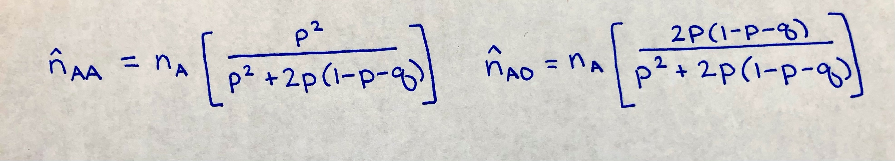

Blood group B:

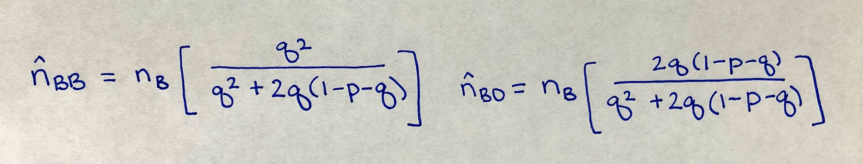

Blood group AB:

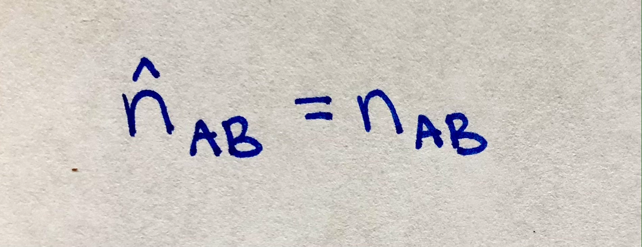

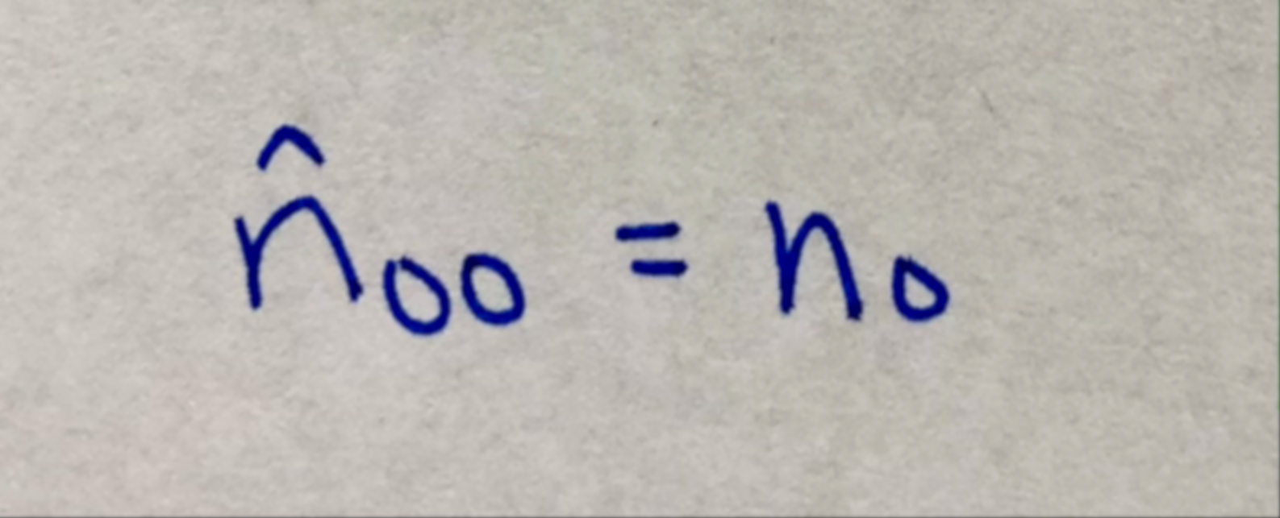Blood group O:

Importantly, these will serve as the **expectation** portion of the EM algorithm.

## **Application of the Expectation-Maximization (EM) algorithm**

Following the set-up of MLE and estimates of genotype frequencies, allele frequencies can be estimated using the allele counting method:

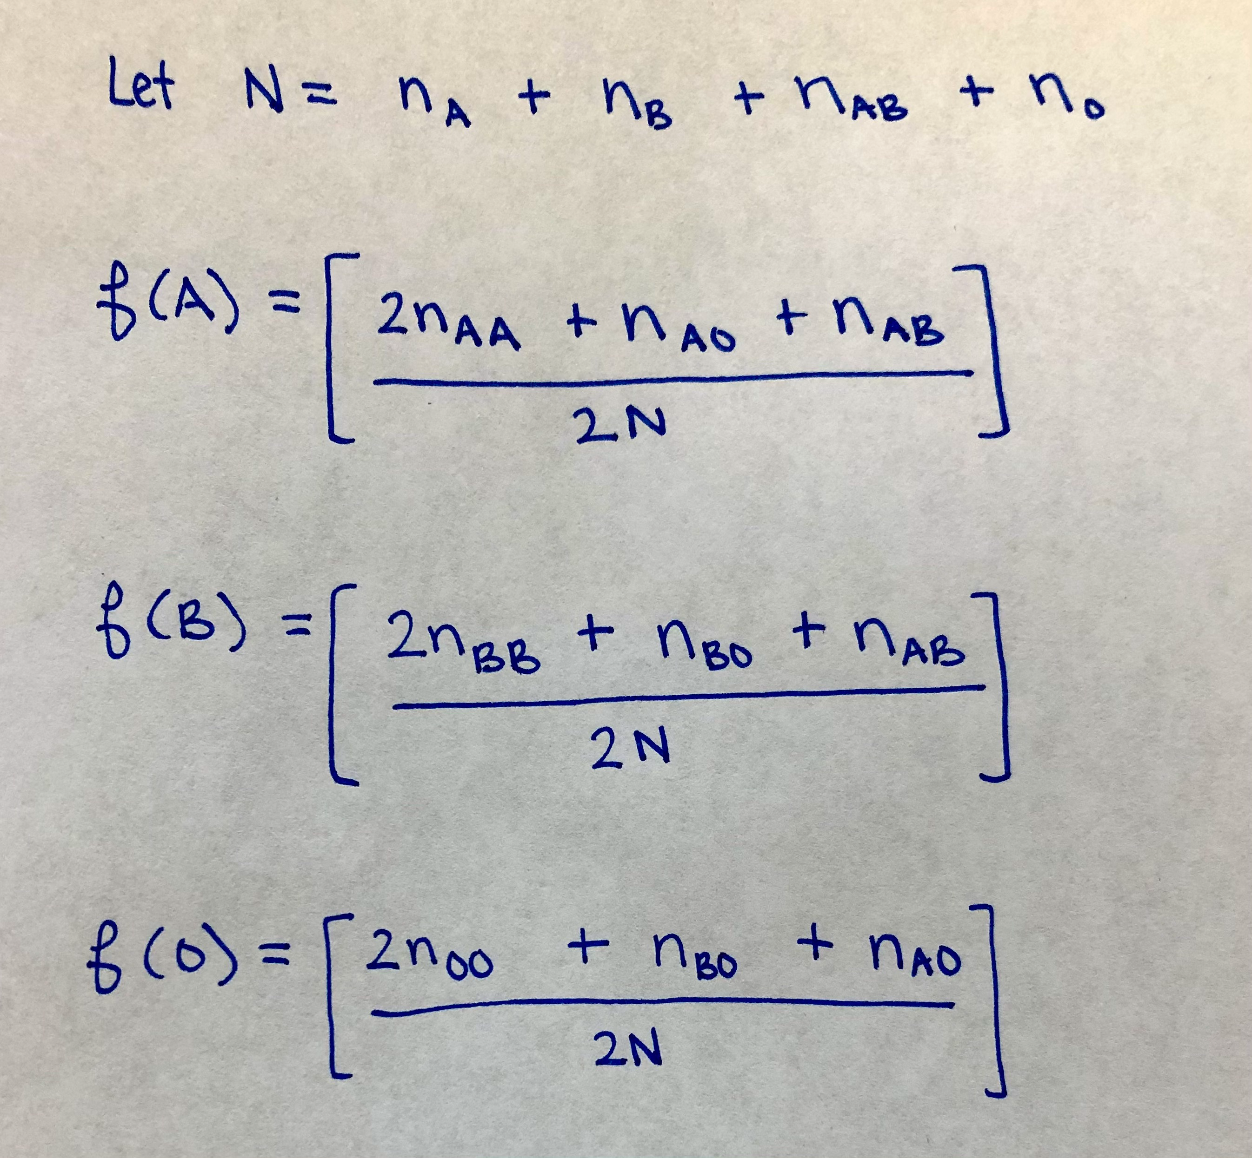

These estimates will serve as the **maximization** portion of the EM algorithm, since the ultimate goal is to determine the maximum likelihood estimates of allelic frequencies given a set of observed counts.

Now that both the expectation and maximization portion of the EM algorithm have been defined, the final consideration is which starting values of *p* and *q* should be used.

Bernstein (1925), as cited by Sun, 2020, provided an approximation based on groupings of phenotypes. Based on this approximation, expected frequencies of blood groups A or O can be determined as follows:

*freq*(*A*, *O*) = *p*2 + 2*p*(1 – *p* – *q*) + (1 – *p* – *q*)2 = (1 – *q*)2

Furthermore, the expected frequencies of blood groups B or O can be determined as follows:

*freq*(*B*, *O*) = *q*2 + 2*q*(1 – *p* – *q*) + (1 – *p* – *q*)2 = (1 – *p*)2

These approximations will serve as the starting values of *p* and *q* EM algorithm

The outcome of the approximation method will serve somewhat as a reference to help determine if 1) the derivatives were achieved correctly and 2) if the algorithms ran successfully. The calculations for the approximate estimates are illustrated below:

Observed frequencies of blood group A or O:

(*nA* + *nO*)/*N* = 16848/21104 = 0.7983

Observed frequencies of blood group B or O:

(*nB* + *nO*)/*N* = 10712/21104 = 0.5076

Therefore, the approximate estimates would be:

(1 – *q*)2 = 0.7983 → = 1 – = **0.106506**

(1 – *p*)2 = 0.5076 → = 1 – $\sqrt{0.5076}$ = **0.287552**

Details regarding the implementation of the EM algorithm can be found in **Figure A2** of the Appendix (add this after when making PDF).

## **4.4 Application of the Newton-Raphson algorithm**

**\*\*Description of how to set up this in a nice way like EM, come back to this (will be Figure A3).** Citation for Newton-Raphson is number **12** in the references list.

# **Results/Conclusion**

Outputs of the two algorithms are summarized in **Table 5.1** (the executionof the algorithmis displayed in **Figure A4**).

|  |  |  |
| --- | --- | --- |
|  | **Expectation-Maximization Algorithm** | **Newton-Raphson Algorithm** |
| ***p*** | 0.2876856 | 0.2876856 |
| ***q*** | 0.106555 | 0.106555 |
| **Tolerance** | 2.251363 x 10-8 | 3.53164 x 10-8 |
| **Iterations** | 6 | 2 |

**Table 5.1. Summary of Expectation-Maximization and Newton-Raphson algorithm outputs.**

Based on the information provided in the table above, one can see that given the right choice of starting values (selected based on Bernstein’s approximation10), the EM algorithm performed quite robustly, converging after 6 iterations. In contrast to this, the Newton-Raphson algorithm required 2 iterations to attain its estimates at the same level of tolerance.

Scientific understanding of blood and its functions, as well as blood groups and their frequencies, may be more sophisticated than ever, but its primal significance and symbolism remains alluring.

# **References**

1. Landsteiner, K. (1901). Ueber agglutinationsersche inungen normalen menschilichen blutes. *Weiner Klinische Wochenschrift,* 14, 1132-1134.
2. The Nobel Prize in Physiology or Medicine. (1930). NobelPrize.org. Nobel Media AB 2020. <https://www.nobelprize.org/prizes/medicine/1930/summary/
3. Dean, L. (2005). *Blood groups and red cell antigens* (Vol. 2). Bethesda, Md, USA: NCBI.
4. Farhud, D.D. & Yeganeh, M.Z. (2013). A brief history of human blood groups. *Iranian Journal of Public Health 42*(1), 1-6.
5. Strachan, T. & Andrew, R. (2011). *Human Molecular Genetics 4th Edition.* Garland Science.
6. Nielsen, R. & Slatkin, M. (2013). *An Introduction to Population Genetics: Theory and Practice*, Sinauer Associates, Inc.
7. Hardy, G.H. (1908). Mendelian proportions in a mixed population. *Science 28*, 49-50.
8. Weinberg, W. (1908). Über den nachweis der verbung beim Menschen. *Jahreshefte des Vereins Varterländische Naturkdunde in Württemberg 64*, 369-382.
9. Andrews, C. (2010). The Hardy-Weinberg Principle. *Nature Education Knowledge 3*(10), 65.
10. Sun, L. (2020, September 22). *Missing data and EM algorithm* [lecture]. University of Toronto, Department of Statistical Sciences, FA, Division of Biostatistics, DLSPH.
11. Dempster, A.P., Laird, N.M. & Rubin, D.B. (1977). Maximum likelihood from incomplete data via the EM algorithm. *Journal of the Royal Society, Series B, 39*(1), 1-38.
12. Raphson, J. (1697). *Analysis Æeuationum Universalis* (in Latin) (2nd. Ed.). Thomas Bradyll.

# **Appendix**